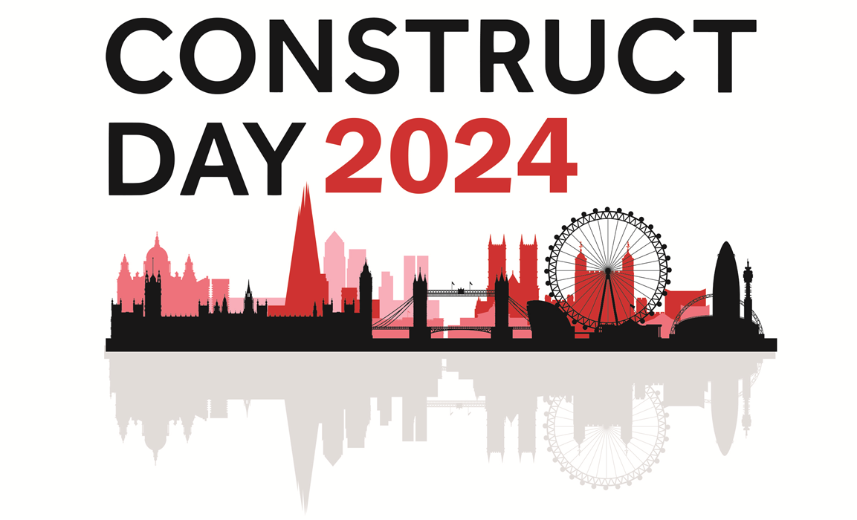

CONSTRUCT DAY 2024 AWARDS ENTRY FORM
PROJECT OF THE YEAR OVER £5M
Company Name
Contact Name
Contact Email
Contact Phone Number

Project Name
Project Address
Construction/Project Type
Completion Date
Project Building Size
Project Cost

Project Description
Project of the Year (Over £5m) Statement:
(Adhere to the minimum 500 and maximum 1000-word count)
Materials
Project of the Year (Over £5m) Summary:
(Summarise your above statement in 150 words that highlights the most important factors that you wish to be announced at Construct Day is awarded)

Please submit a minimum of three high quality images with your entry.

Please submit your entry to rosie.canty@construct.org.uk by 28th June 2024.

