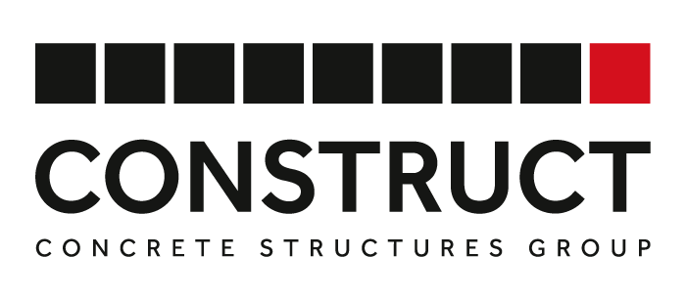
CONSTRUCT DAY 2024 AWARDS CRITERIA
PROJECT OF THE YEAR OVER AND UNDER £5M
These two award categories recognise projects within the Concrete Structures Industry. Please fill in either form based on your project costs.
Please note projects must be within the UK and the Republic of Ireland and have completed after 1st January 2023.
Please see the below guidance that should be used as a basis for your written statement.
Project Description | - What type of building is your project involved in?  - What part/s of the building or project did your company specifically work on?  - How long did it take to complete?
Materials | - Please list the materials that you used on the project as well as manufacturers and suppliers.  - Explain your specific choices for the materials, if necessary.
Statement  (500–1000-word count) | Information to include:  - Process and product innovation.  - Overcoming complexity – include any specific challenges.  - Examples of high-quality workmanship in the project.  - Exceeding client’s expectation (cost/time).  - Repeatability.  - Use of technology.  - Low wastage.
Top Tips: | - Write clearly and concisely and make sure your entry covers all the key points. Whilst you are familiar with the project, the person reading the entry will not be, so please explain any technical jargon fully and why it is relevant.  - Pay attention to detail including spelling and punctuation.  - Facts and figures are a great way to strengthen your entry and a client testimonial can provide a valuable support for your project.  - Adhere to the minimum word count of 500 and the maximum of 1000.

Your entry should be accompanied by three high-quality images.

